List Comprehension

Q: What is comprehension?
Comprehensions in Python provide a concise and efficient way to create new collections (lists, dictionaries, sets, or generators) from existing ones in a single line of code, offering a readable and "Pythonic" alternative to traditional loops. They encapsulate the logic for iteration, transformation, and filtering.

Types of comprehension
Types of comprehension are nothing but comprehension is used for which type of collections.
- List Comprehension
- Set Comprehension
- Dictionary Comprehension

List Comprehension
List comprehension offers a shorter syntax when you want to create a new list based on the values of an existing iterable or collection.
List comprehension allows to write logic of iteration, transformation and filtering within [] (Square Brackets)

A=[10,20,30,40,50] 🡺 List with elements or Values
B=[] 🡺 Empty list

Syntax1: [expression for variable in iterable]
Syntax2: [expression for variable in iterable if test]

Syntax1: [expression for variable in iterable/iterator]
In this syntax after iterating each value generated by iteable, it evaluates expression.

Expression is evaluated and stored inside list based on number of values generated by iterable or iterator.

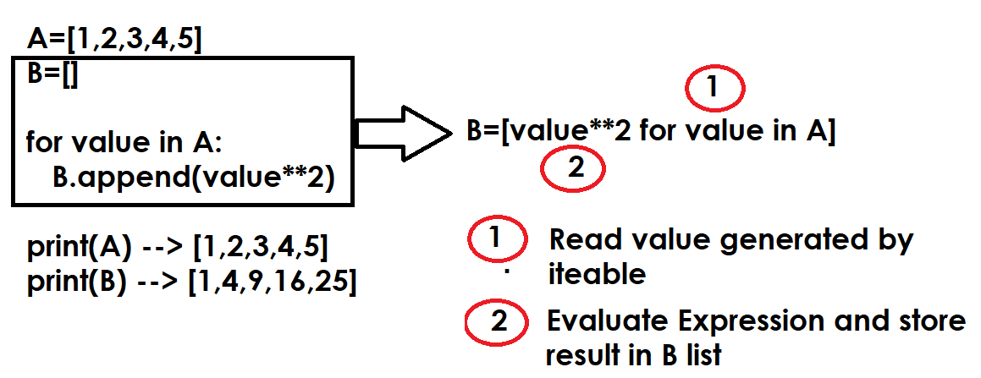
Example:
# Creating list using list comprehension

A=[num for num in range(1,11)]
print(A)
B=[num**2 for num in range(1,11)]
print(B)
C=[chr(n) for n in range(65,91)]
print(C)
D=[chr(n) for n in range(97,123)]
print(D)
E=[[n,chr(n)] for n in range(65,91)]
print(E)
F=[[num,num**2] for num in range(1,11)]
print(F)

Output
[1, 2, 3, 4, 5, 6, 7, 8, 9, 10]
[1, 4, 9, 16, 25, 36, 49, 64, 81, 100]
['A', 'B', 'C', 'D', 'E', 'F', 'G', 'H', 'I', 'J', 'K', 'L', 'M', 'N', 'O', 'P', 'Q', 'R', 'S', 'T', 'U', 'V', 'W', 'X', 'Y', 'Z']
['a', 'b', 'c', 'd', 'e', 'f', 'g', 'h', 'i', 'j', 'k', 'l', 'm', 'n', 'o', 'p', 'q', 'r', 's', 't', 'u', 'v', 'w', 'x', 'y', 'z']
[[65, 'A'], [66, 'B'], [67, 'C'], [68, 'D'], [69, 'E'], [70, 'F'], [71, 'G'], [72, 'H'], [73, 'I'], [74, 'J'], [75, 'K'], [76, 'L'], [77, 'M'], [78, 'N'], [79, 'O'], [80, 'P'], [81, 'Q'], [82, 'R'], [83, 'S'], [84, 'T'], [85, 'U'], [86, 'V'], [87, 'W'], [88, 'X'], [89, 'Y'], [90, 'Z']]
[[1, 1], [2, 4], [3, 9], [4, 16], [5, 25], [6, 36], [7, 49], [8, 64], [9, 81], [10, 100]]

Example:
# Write a program to create 2x2 matrix and display

# Without Comprehension
A=[]

for i in range(2):
row=[]
for j in range(2):
value=int(input("Enter value "))
row.append(value)

A.append(row)

print(A)

# with comprehension
B=[[int(input("Enter Value")) for j in range(2)] for i in range(2)]
print(B)

Output
Enter value 1
Enter value 2
Enter value 3
Enter value 4
[[1, 2], [3, 4]]
Enter Value5
Enter Value6
Enter Value7
Enter Value8
[[5, 6], [7, 8]]

Example:
A=["naresh","ramesh","kishore","rajesh","kiran"]
B=[name.upper() for name in A]
print(A)
print(B)
C=[]
for name in A:
C.append(name.upper())
print(C)

Output
['naresh', 'ramesh', 'kishore', 'rajesh', 'kiran']
['NARESH', 'RAMESH', 'KISHORE', 'RAJESH', 'KIRAN']
['NARESH', 'RAMESH', 'KISHORE', 'RAJESH', 'KIRAN’]

Syntax2: [expression for variable in iterable if test]
Syntax2 is used for filtering data
Syntax2 allows evaluating expression based on condition.

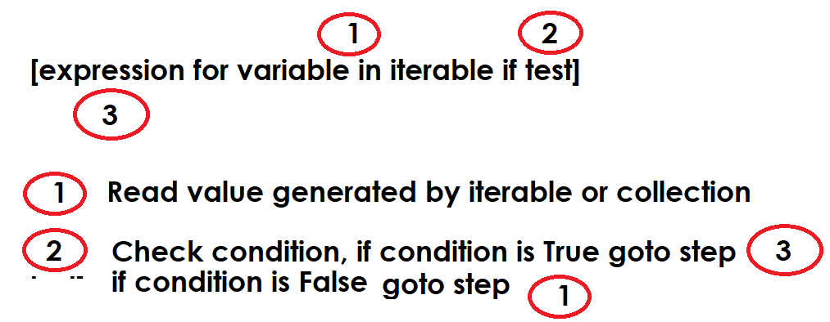

Example:
A=[1,8,23,76,98,5,7,9,21,37,75,89,98,67,44,63]
print(f'List is {A}')
#Filter Even Numbers
B=[num for num in A if num%2==0]
print(f'Even Numbers List {B}')
#Filter Odd Numbers
C=[num for num in A if num%2!=0]
print(f'Odd Numbers List {C}')

Output
List is [1, 8, 23, 76, 98, 5, 7, 9, 21, 37, 75, 89, 98, 67, 44, 63]
Even Numbers List [8, 76, 98, 98, 44]
Odd Numbers List [1, 23, 5, 7, 9, 21, 37, 75, 89, 67, 63]

Example:
grade_list=[['naresh','A'],
['suresh','B'],
['ramesh','A'],
['rajesh','A'],
['rakesh','B'],
['kiran','C']]

print(grade_list)
grade_listA=[stud for stud in grade_list if stud[1]=='A']
grade_listB=[stud for stud in grade_list if stud[1]=='B']
grade_listC=[stud for stud in grade_list if stud[1]=='C']

print(grade_listA)
print(grade_listB)
print(grade_listC)

Output
[['naresh', 'A'], ['suresh', 'B'], ['ramesh', 'A'], ['rajesh', 'A'], ['rakesh', 'B'], ['kiran', 'C']]
[['naresh', 'A'], ['ramesh', 'A'], ['rajesh', 'A']]
[['suresh', 'B'], ['rakesh', 'B']]
[['kiran', 'C']]

Example:
# Write a program to add 2x2 matrices using list comprehension

print("Enter Elements of first matrix")
A=[[int(input("Enter value ")) for j in range(2)] for i in range(2)]
print("Enter Elements of second matrix")
B=[[int(input("Enter Value ")) for j in range(2)] for i in range(2)]
C=[[A[i][j]+B[i][j] for j in range(2)] for i in range(2)]

print(A)
print(B)
print(C)

Output
Enter Elements of first matrix
Enter value 1
Enter value 2
Enter value 3
Enter value 4
Enter Elements of second matrix
Enter Value 5
Enter Value 6
Enter Value 7
Enter Value 8
[[1, 2], [3, 4]]
[[5, 6], [7, 8]]
[[6, 8], [10, 12]]

Tuple
Tuple is an immutable sequence data type.
After creating tuple changes cannot done.
Tuple does not support mutable operations like,
- Append()
- Extend()
- Remove()
- Sort()
- Insert()
- Replace()
- Del keyword
In application development tuple is used to represent immutable list.

